# Childville Website/App

## About this Project

This project sets to create a dynamic web app for a preschool institution.



### Intro

**There is an emphasis** on the web app having a mobile first design.

##### Remember to:

Use large colourful texts and Use colourful images which appeals to children and parents

Web App would have two sections.

#### General Section

Which the public would be able to access.

#### Staff Section

Which only staﬀ of the institution are able to access.



* 1. **General**

**The following features are required**

* + - **Home**.
    - **About Us**
    - **Contact Us**
    - **Photobook**
    - **Branches**
    - **Testimonial**
    - **Staff**



### 1.1.1 Home

##### Should have the following

A section which describes the major sections of the school (i.e creche or day care and a little information about what is done)

A bit of About Us with a button to read more. Add an image to the right (or below in small screens).

Some information on why this school can be chosen. A heading, an intro subheading, and 2-3 points with each point having a colorful diagram as marker.

A testimonial section (if any)

Some carousel of recent pictures from the gallery (photobook)



**1.1.2 About Us**

Contain information about the institution, it’s history, mission and vision statements.



### Contact Us

##### Should have the following

School opening hours (for parent visit or enquiries)

Way to message the school by sending a message here Phone and Email Address

Location

Social Media handles (if any)

A google map showing the school’s location would be cool.



## INTERLUDE

A brief break to catch our breaths



### Photobook

Show lots of photos showcasing children, events in the institution and the facilities/infrastructure.

Show some textual description with each image.

An initial carousel of recent images to be shown on the top.

Images can be grouped into sections or tags.



**1.1.5 Branches**

Details of the other branches of this institution with directions, and maybe contacts, and names of the director in each branch if possible.



**1.1.6 Testimonial**

If required, would contain some pictographic information from satisfied parents and clients.



**f.f.y Staff**

Each staﬀ would have a *card* widget having name, photo, position, educational qualifications and/or experiences.



**Tip**

This section is accessed via a **login** link/button amongst the menus or on the home or staﬀ page.

### Staff Section

Only accessible to staff who will have to login with a username and a password.

Username and Passwords will be created by an admin for each staff who will then have to fill in the other necessary information.

### Staff Profile.

* Name



* Job Title (or position)
* Last logged in (Datetime)
* Date Joined
* Bio
* Username
* Password
* Phone
* Email
* Photo
* Emergency Contact

*Story for illustration purposes only*

#### Tip

A staﬀ should have a colourful photo smiling widely and being expressive.

As appropriately informal and playful as possible.



### Staff Profile Contd.

* Date of birth
* Bank Details
* Pay (should have it’s model)
* Job Start Date
* Job Location
* Job supervisor
* Yearly Performance
* Set goals
* Reviews and Assessments

*Some of these information will be on related models*



1. **Staff**

Should be able to

* + **Rota**

Which schedules he/she is participating in or has been assigned to.

* + **Payslip**

See current Payslip.

* + **Time Off**

Request Time Oﬀ and track responses.

# An Admin

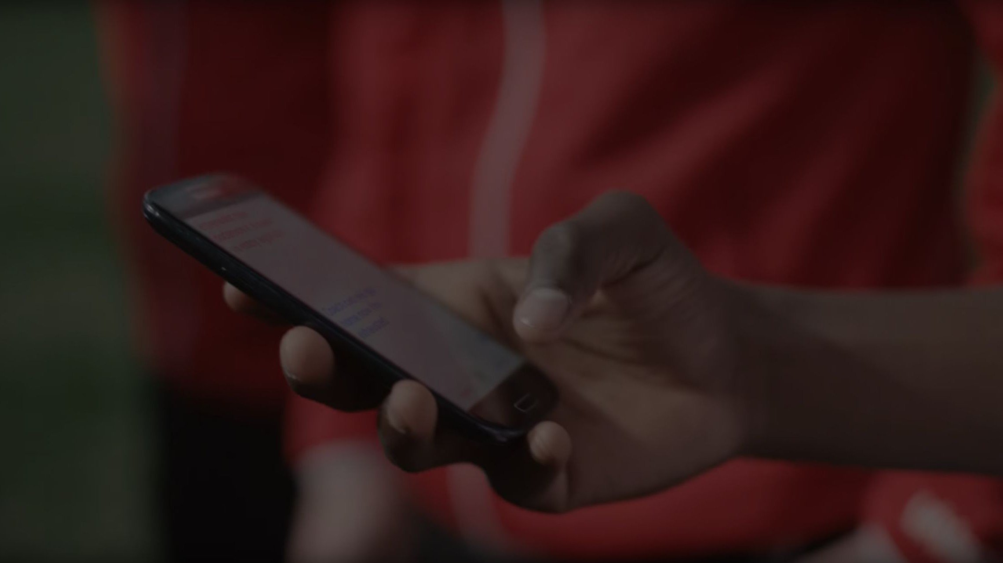

* **Should be able change the passwords of all staff.**
* **Carry out assessment of all staff**
* **Create other roles (such as a supervisor)**
* **Upgrade a staff to admin**
* **Get notified when a staff changes some profile data.**
* **Create rota (where each staff is assigned a task or responsibility at a certain date)**
* **Should not be able to change all information on a staff, only specified information such as**

**pay-related.**

#### Tip

Ideally, If the institution is large, a supervisor can set the pay of junior staﬀ, then an admin set the pay of supervisors.

### Milestones

**March 25th – 15th April**

2024

Gather requirements

Develop Staff and Admin section of the web app **April 15th – 19th 2024**

Testing and Deployment Phase

|  |
| --- |
|  |

# Project Tools

**FrontEnd**

Materialize CSS HTML, JS and CSS

**Backend**

Django

**Database**

Postgresql

**IDE & Other Tools**

Git Pycharm

**Hosting would be done on** [**Namecheap**](https://www.namecheap.com/)**.**



#### Tip

NameCheap does not oﬀer support for Django, so a VPS would have to be used.

**Attribution**

* Freepiks
* Google Slides